***Understanding the JSON Format and Working with JSON***

**JSON:** JavaScript Object Notation

**XML:** eXtensible Markup Language

Yahoo weather APIs

**JSON v XML**

<https://www.w3schools.com/js/js_json_xml.asp>

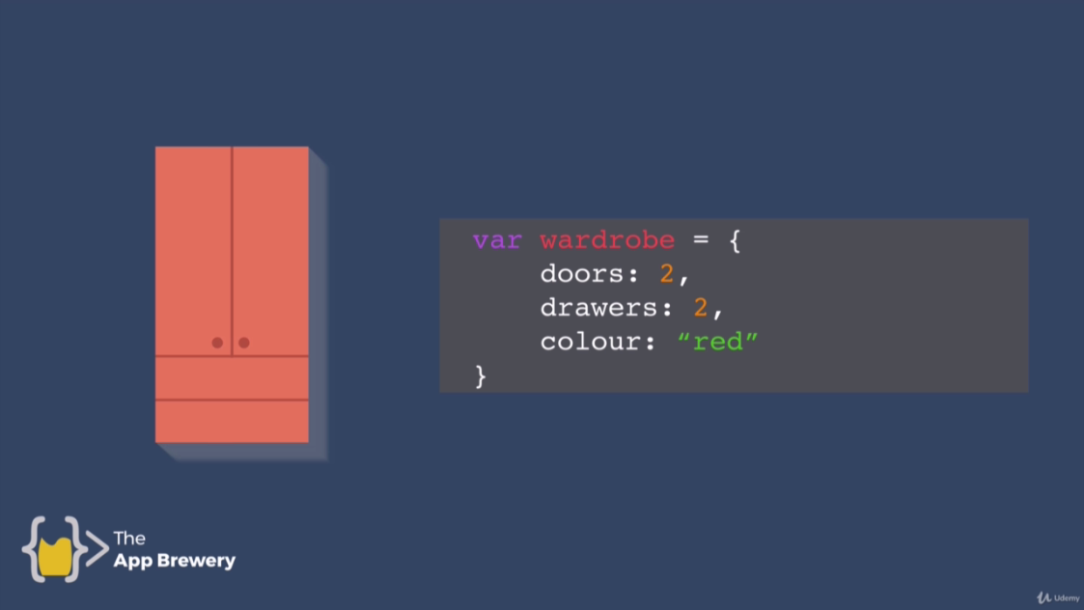



This is equivalent to converting JS to JSON. And it is shorter and easier.

We can easily convert JSON data to JS.

**var wardrobe = {**

**door : 2,**

**drawers : 2,**

**colour : "red"**

**}**

**JSON.stringify(wardrobe);**

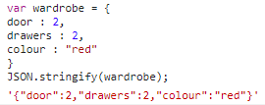

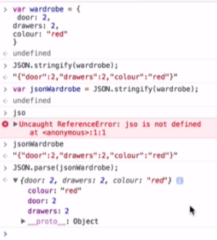

Add **JSON Viewer Awesome** to extensions

JSON Viewer Pro

<https://apiv2.bitcoinaverage.com/indices/global/ticker/BTCUSD>